SAPPHIRE PRO MACHINE WITH NEEDLES AND ACCESSORIES
Machine Kit R3200.00
Needles (3 prong) R35
Coupler R14
Casing R35
Tip R11
TOTAL R95
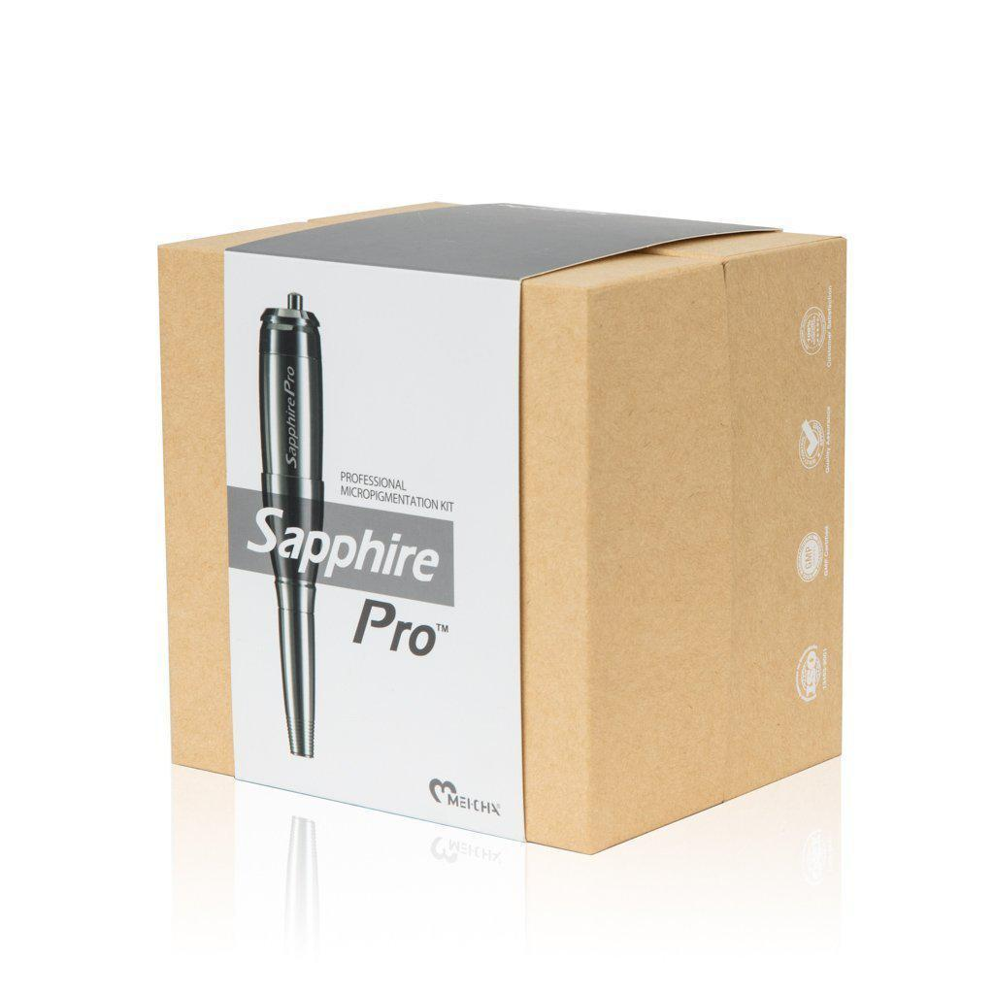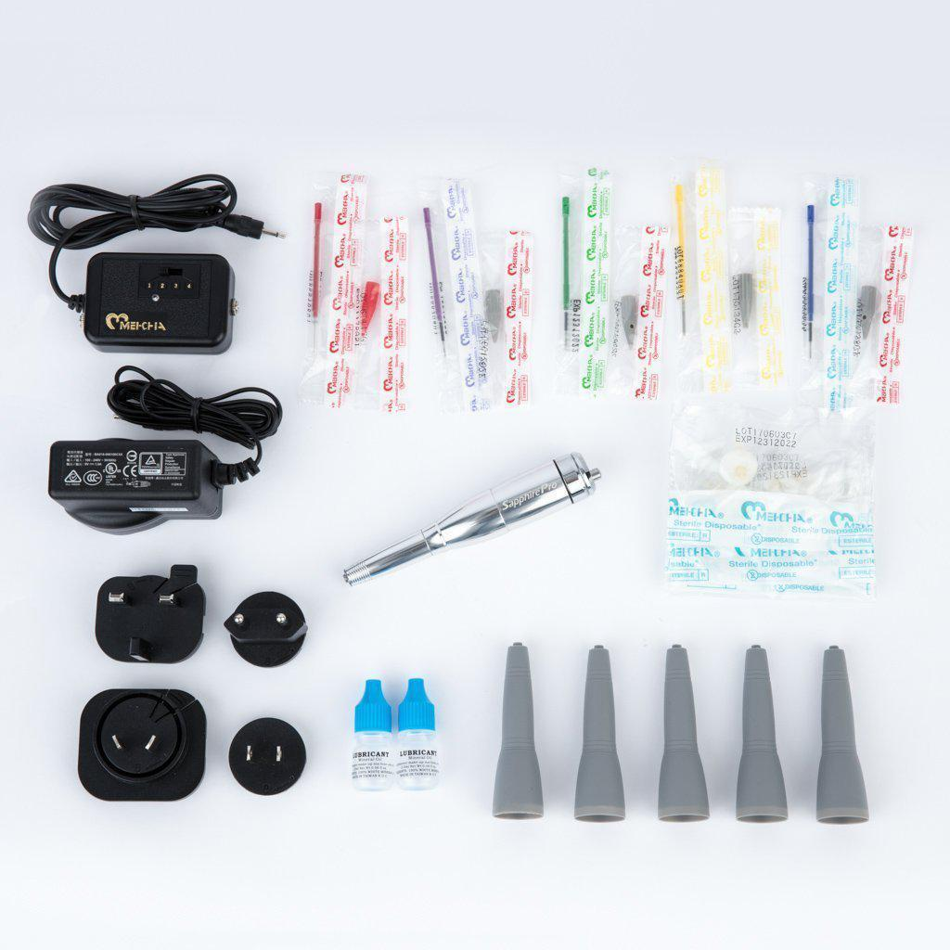
SAPPHIRE ELITE KIT WITH ACCESSORIES
Machine Kit R5300.00
Needle (tip combo) R48.00
Casing (blue) R35.00
Coupler R14.00
TOTAL R97.00
